**Supplemental Material: Temporal association between sleep slow oscillations, spindles and ripples.**

Carlos N. Oyanedel†1,2, Ernesto Durán†1,2,3, Niels Niethard1, Marion Inostroza1, Jan Born1,4*

1 Institute of Medical Psychology and Behavioral Neurobiology, University of Tübingen, Tübingen, Germany.

2 Graduate School of Neural & Behavioural Science, International Max Planck Research School, Tübingen, Germany.

3 Laboratorio de Circuitos Neuronales, Departamento de Psiquiatría, Centro Interdisciplinario de Neurociencias, Pontificia Universidad Católica de Chile, Santiago de Chile, Chile.

4 Centre for Integrative Neuroscience (CIN), University of Tübingen, Tübingen, Germany.

† These authors contributed equally to this work

**\* Corresponding author:**

Jan Born, Institute of Medical Psychology and Behavioral Neurobiology, Otfried-Müller-Str. 25, 72076 Tübingen, Germany. E-mail: [jan.born@uni-tuebingen.de](mailto:jan.born@uni-tuebingen.de)

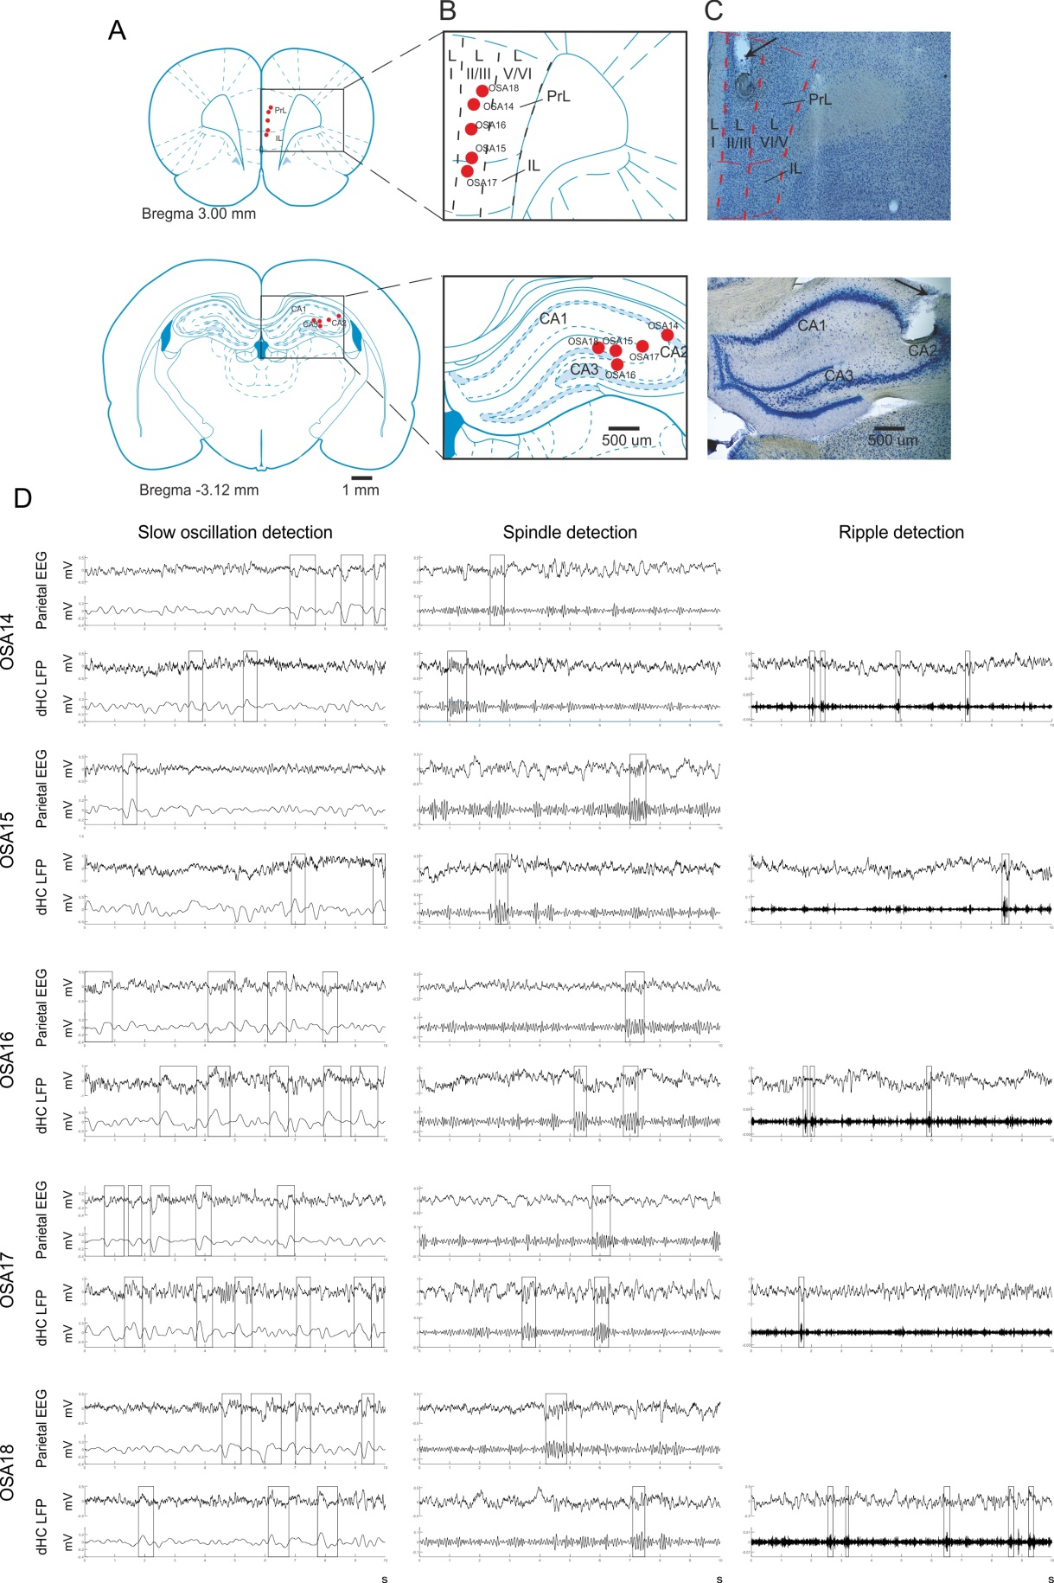

**Supplemental Figure S1. Histological verification and reconstruction of the electrode placement in mPFC and dHC.** (A) Coronal rat brain atlas diagrams adapted from Paxinos and Watson (1998) indicating the electrode position for mPFC (top) and dHC (bottom) LFP recordings. (B) Maps of electrode positions for mPFC (top) and dHC (bottom) LFP recordings (red dots). (C) Coronal view of an example methylene blue-stained section of the mPFC (top), with parcellation of layers I, II/III, and V/VI and electrode position indicated (arrow). Bottom, example section from same animal of dHC. (D) Example traces of LFP recordings from dHC and simultaneous parietal EEG recordings from individual animals (OSA14-OSA18). Unfiltered signals (upper trace) and signals filtered in the frequency band for identifying SOs, spindles, and ripples (lower trace) are shown (identified oscillatory events framed). Note, for example SOs (left panels) can occur in parietal recordings in the absence of any similar SO in dHC recordings excluding strong volume conductance of the signal between channels. Recording polarity was determined based on wave shape characteristics of SOs. LFP = Local field potential; mPFC = Medial prefrontal cortex; dHC = Dorsal hippocampus.

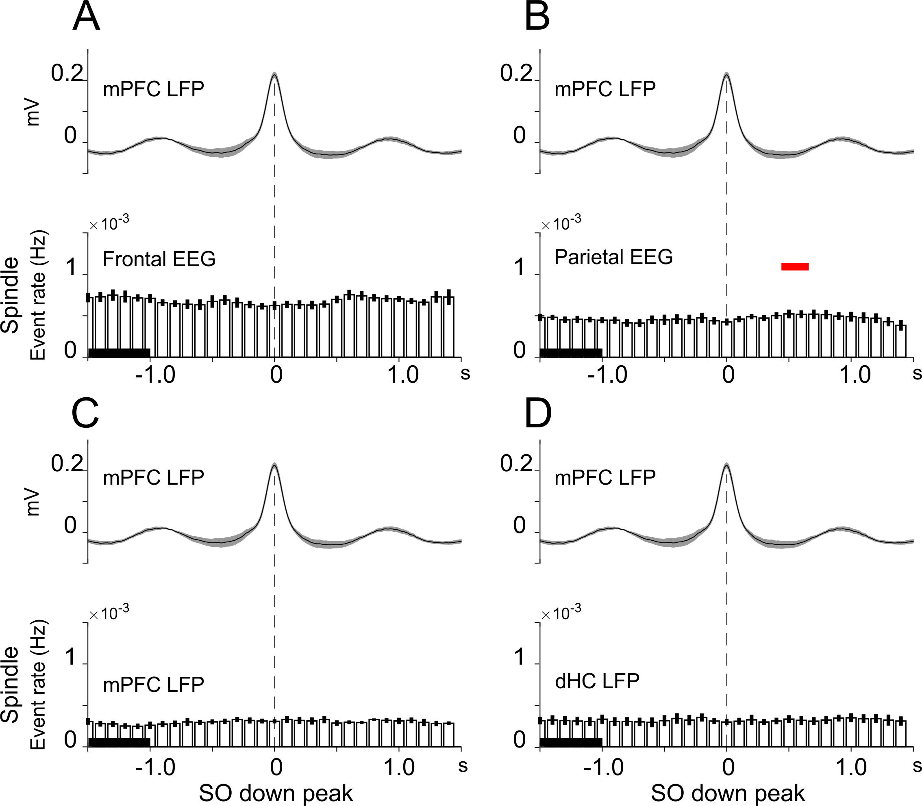

**Supplemental Figure S2. Temporal association between SO events in mPFC and spindles in EEG and LFP recordings**. Event correlation histogram of spindle events time-locked to the downstate peak (0 s, vertical dashed lines) of SOs identified in mPFC LFP recordings. Spindle events were identified in (A) frontal EEG, (B) parietal EEG, (C) mPFC LFP, and (D) dHC LFP signals. Event rate (in Hz) refers to spindle events quantified by all peaks and troughs of an identified spindle. Means (±SEM) rates across all SO epochs with co-occurring spindles (in one of the four channels) from 5 rats are shown. Bin size: 100 ms. Graphs above the histograms show the mean (±SEM) reference SO in mPFC recordings, time-locked to the SO downstate peak. Significant increases in event rates are indicated (red lines: *p* < 0.05, for pairwise comparison with a 1-s baseline interval (-2.0 to -1.0 s)).

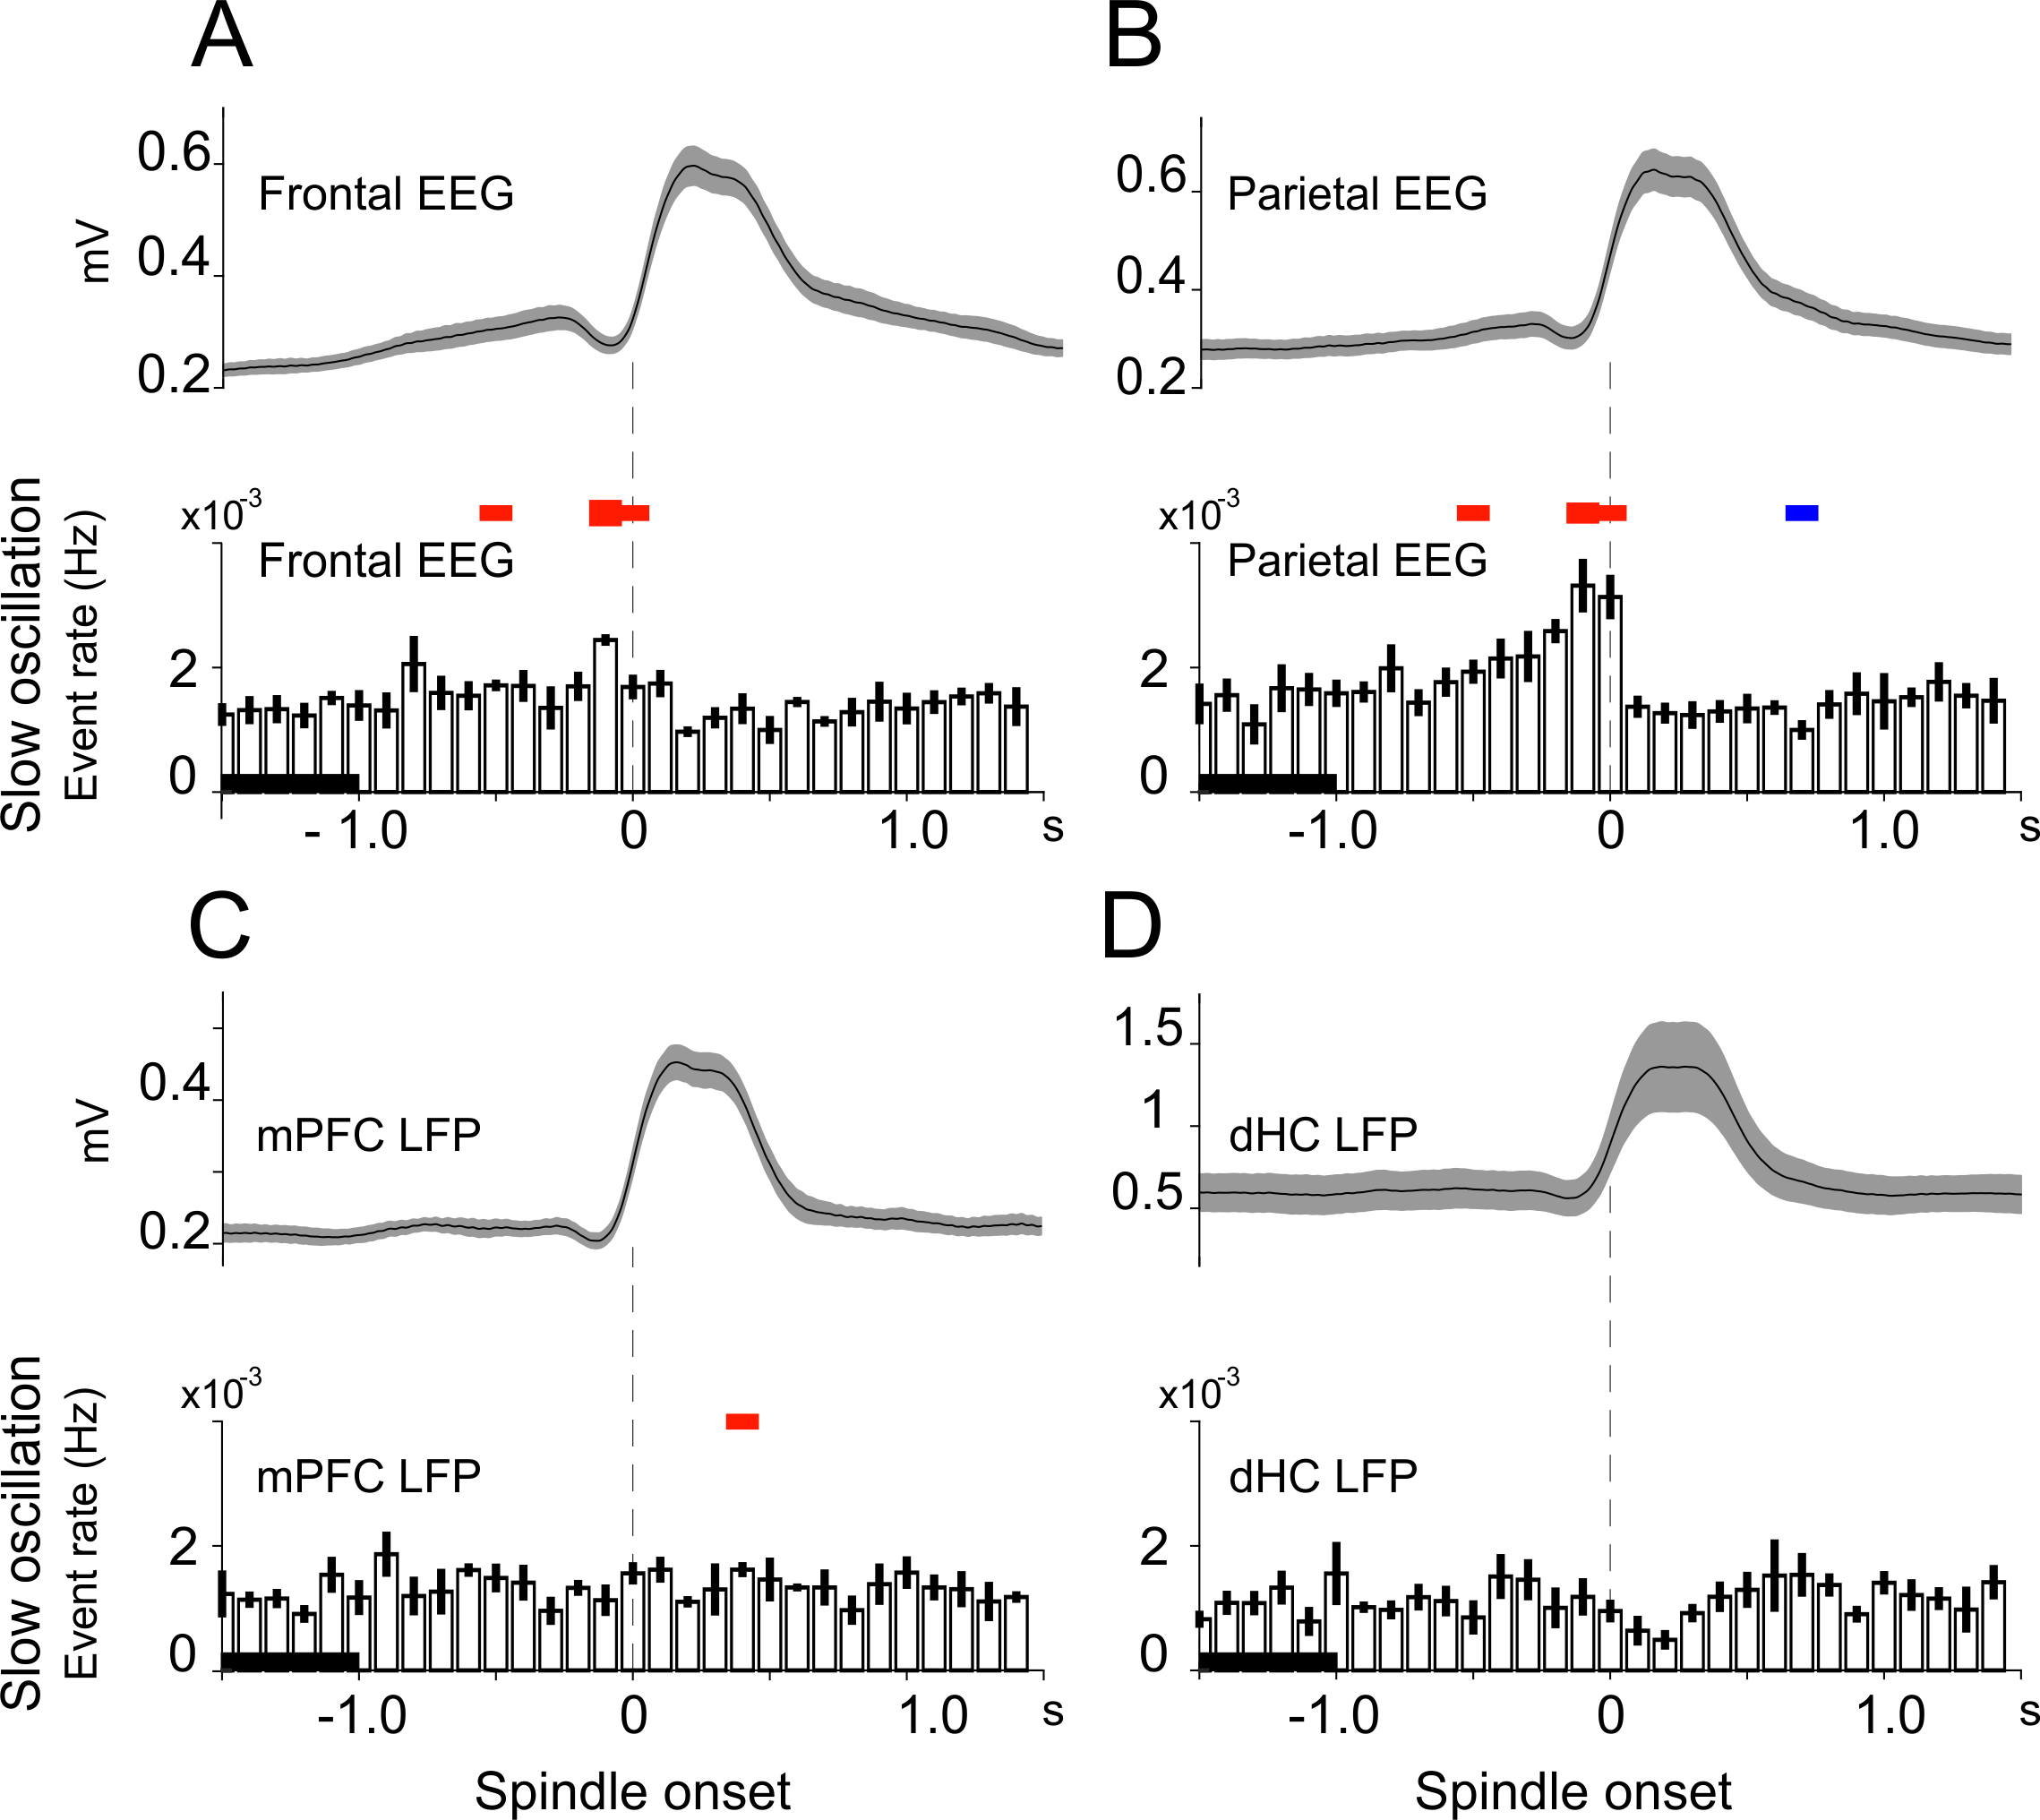

**Supplemental Figure S3. Temporal association between spindles and SOs.** Event correlation histogram of SO events time-locked to the onset of spindles (0 s, vertical dashed lines) in (A) frontal EEG, (B) parietal EEG, (C) mPFC LFP, and (D) dHC LFP signals. Event rate (in Hz) refers to SO events identified by their downstate peak. Mean (±SEM) rates across all spindle epochs with co-occurring SOs from 5 rats are shown. Bin size: 100 ms. Graphs above the histograms show mean (±SEM) root mean square amplitude of the respective reference spindles, time-locked to the spindle onset. Significant increases (red) or decreases (blue) in spindle occurrence are indicated (thin lines: *p* < 0.05; and thick lines: *p* < 0.001, for pairwise comparison with a 1-s baseline interval (-2.0 to -1.0 s)).

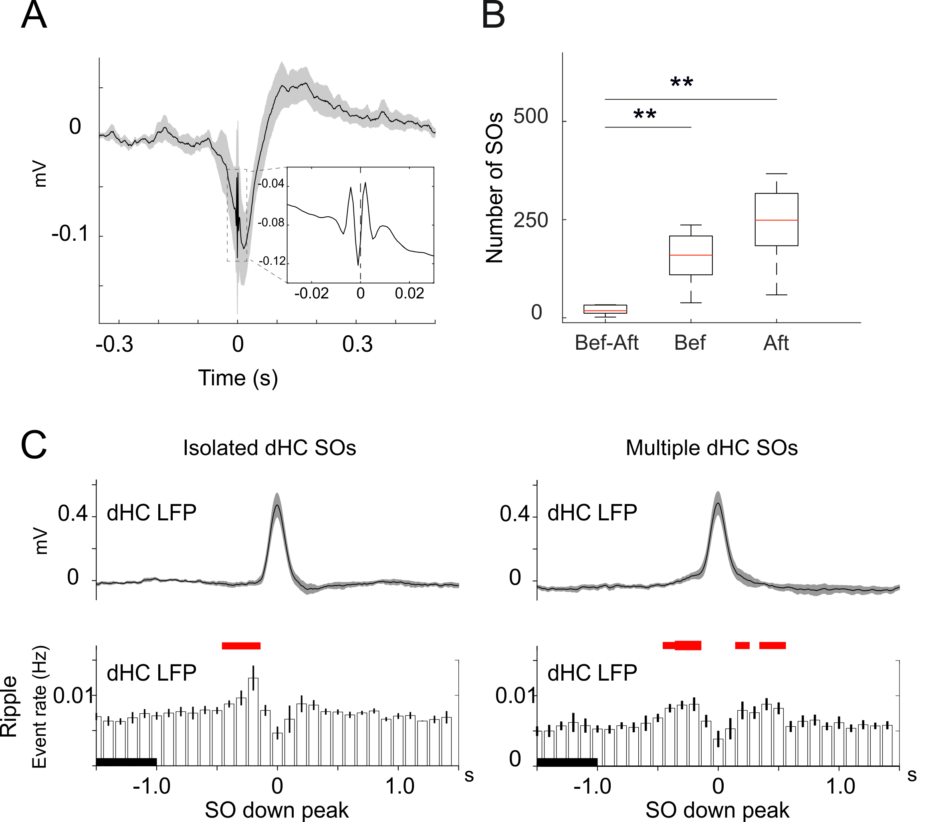

**Supplemental Figure S4. Hippocampal ripples before and after SO downstate peaks.** (A) Grand average (±SEM) of ripple from the unfiltered dHC LFP signal time-locked to the maximum ripple trough. Insert illustrates a single ripple. (B) Number of SO events with ripple events before and after the downstate peak (Bef—After), and with ripple event either before (Bef) or after (Aft) the downstate peak. Box-whisker plots indicate median, upper (top) and lower (bottom) quartiles. * *p* < 0.05; ** *p* < 0.01 for pairwise comparison. (C) Event correlation histograms of ripple events time-locked to the SO downstate peak (0 s, vertical dashed lines) for SO events in dHC LFP recordings that (left) either occurred in isolation (n = 1753.6 ± 495.7), or (right) were preceded or followed (within ± 1.5 ms) by another SO event, i.e., downstate peak (n = 1375.0 ± 343.0). Event rate (in Hz) refers to events quantified by all troughs and peaks of an identified ripple. Mean (±SEM) rates across all respective SO epochs with co-occurring ripples from 5 rats are shown. Graphs above the histograms show means (±SEM) for the respective reference SOs, time-locked to the SO downstate peak. Bin size 100 ms. Significant increases (red) or decreases (blue) in ripple occurrence are indicated (thin lines: *p* < 0.05; and thick lines: *p* < 0.001, for pairwise comparison with a 1-s baseline interval (-2.0 to -1.0 s)). Note, on average stronger increase in ripple activity before the downstate peak of SOs occurring in isolation than before SOs followed by another SO.

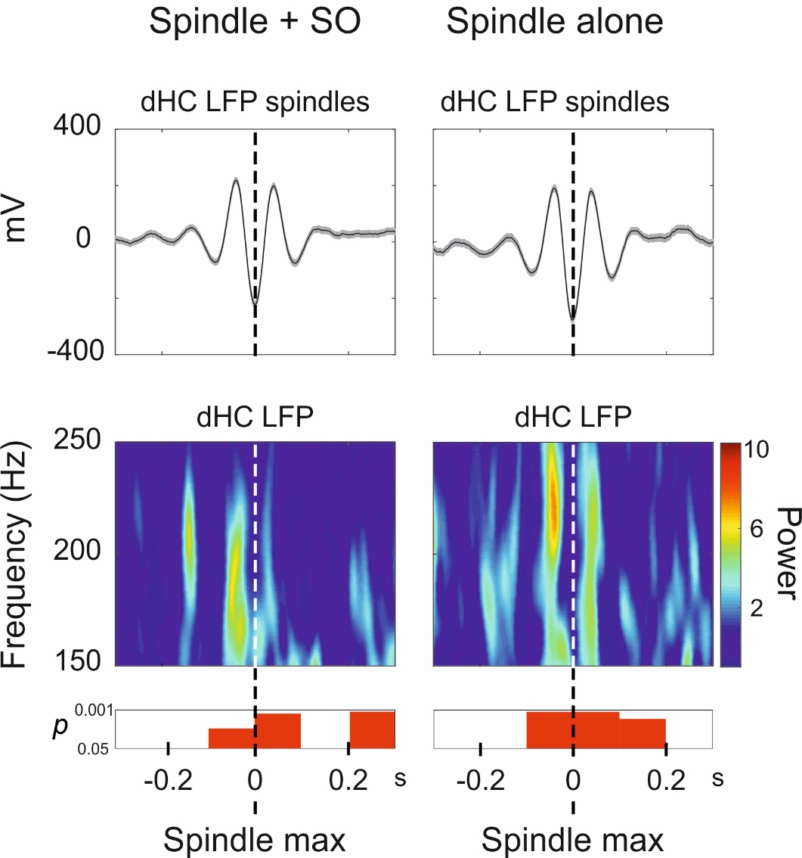

**Supplemental Figure S5. Hippocampal ripple power during spindles.** Top panels: Grand average (±SEM) spindle from unfiltered dHC LFP signal during a ±0.3-s interval around the maximum trough of the spindle (0 s) for spindles co-occurring with an SO (left, n = 138) and isolated spindles occurring in the absence of an SO event (right, n = 469). Unlike in Fig. 6 of the main text, here both spindles as well as SOs were detected in dHC LFP recordings. Co-occurrence of an SO was indicated when an SO downstate occurred within the ±1.5-s interval around the spindle maximum trough. Bottom panels: Time-frequency plots of power in the 150–250 Hz frequency band of the dHC LFP signal time-locked to the maximum trough of reference spindle (0 s). Power is color-coded and given as normalized value, i.e., divided by the average power during a baseline interval (-2.0 to -1.0 s). Significant differences (increases) from baseline values are indicated underneath (*p*-values for paired-sample *t*-test, uncorrected).

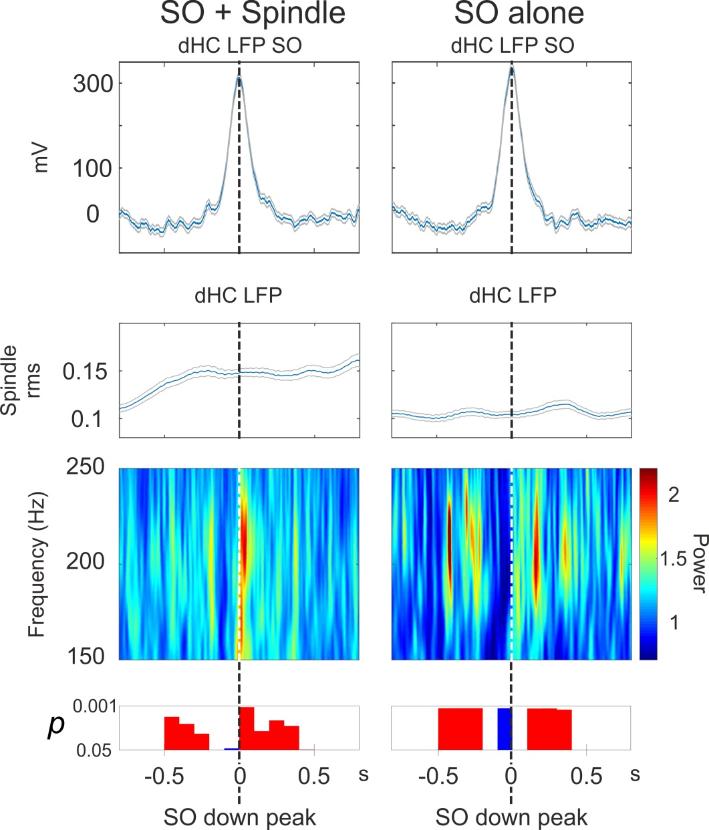

**Supplemental Figure S6. Hippocampal ripple power during slow oscillations (SOs).** Top panels: Grand average (±SEM) SOs from unfiltered signals during a ±0.8 s-interval around the downstate peak of the SO (0 s) for SOs co-occurring with a spindle (left) and SOs occurring in the absence of a spindle event (right). Unlike in Fig. 7 of the main text, here, both SOs and spindles were only detected in dHC LFP recordings. The co-occurrence of a spindle was indicated when a spindle onset occurred within the ±1.8 s-interval around the SO downstate peak. Middle panels: root mean square amplitude for the dHC LFP signal filtered in the spindle frequency band (10.0 – 16.0 Hz). Bottom panels: Time-frequency plot of power in the 150.0-250.0 Hz frequency band of the dHC LFP signal time-locked to the downstate peak of reference SO (0 s). Power is color-coded and given as normalized value, i.e., divided by the average power during a baseline interval (-2.0 to -1.0 s). Significant differences (increases: red, decreases; blue) from baseline values are indicated underneath (*p*-values for paired-sample *t*-test, uncorrected). Note, consistent with the analyses in Fig. 7 of the main text (collapsing SOs across all recording sites), upstates of SOs selectively identified in dHC recordings are associated with increased ripple power, whereas ripple power is decreased around the downstate of these SOs, particularly when they occur in the absence of a spindle. As a result, ripple power ~100 ms around the SO downstate peak is significantly lower (*p* < 0.05) for isolated SOs than SOs co-occurring with a spindle (not shown). Different from the analysis in Fig. 7, the upstate-related increase in ripple power during SOs occurring alone in the dHC LFP signal appears to be more persistent, likely reflecting that once a SO has reached the hippocampus, the upstate per se can effectively contribute to increasing ripple activity.

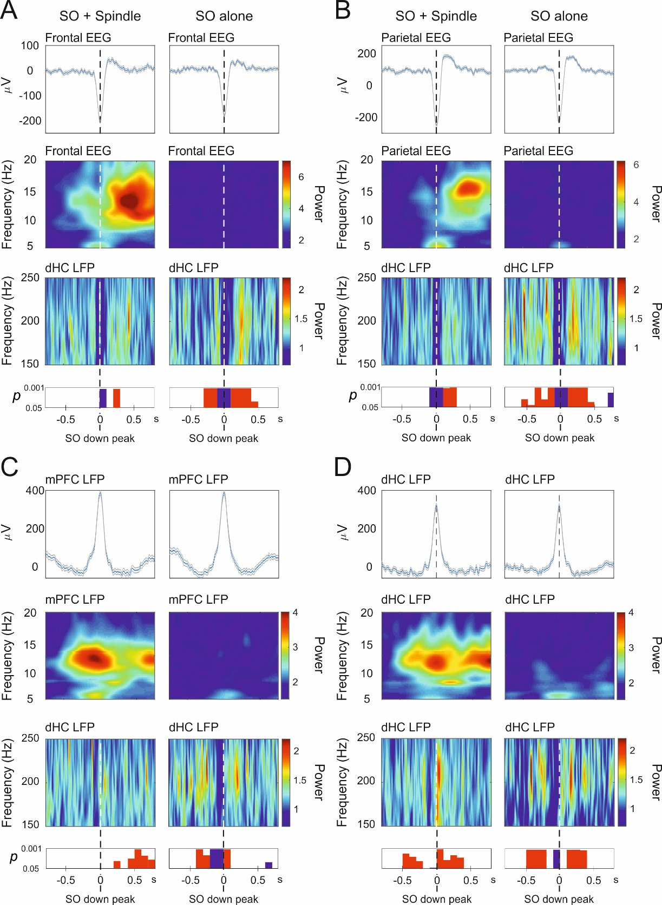

**Supplemental Figure S7. Hippocampal ripple power during slow oscillations (SOs).** Top panels: Grand average (±SEM) SOs from unfiltered signals from (A) frontal EEG, (B) parietal EEG, (C) mPFC LFP, and (D) dHC LFP, during a ±0.8 s-interval around the downstate peak of the SO (0 s) for SOs co-occurring with a spindle (left) and SOs occurring in the absence of a spindle event (right) with the spindle identified in the same channel as the SO. The co-occurrence of a spindle was indicated when a spindle onset occurred within the ±1.8 s-interval around the SO downstate peak. Middle panels: Time-frequency plot of power in the 5.0-20.0 Hz band (covering the spindle band) time-locked to the downstate peak of the reference SO (0 s). Bottom panels: Time-frequency plot of power in the 150.0-250.0 Hz frequency band of the dHC LFP signal time-locked to the downstate peak of reference SO (0 s). Power is color-coded and given as normalized value, i.e., divided by the average power during a baseline interval (-2.0 to -1.0 s). Significant differences in ripple band power (increases: red, decreases: blue) from baseline values are indicated underneath (*p*-values for paired-sample t-test, uncorrected). Except that ripple power around the downstate peak (0 s) of SOs co-occurring with spindles was higher with event detection in the dHC LFP than in EEG recordings (*p* < 0.05), there were no significant differences in ripple power depending on the site of SO/spindle detection.